To Replace the Word "hello" with "hi" Using Lex.
AIM:
To write a Lex program to replace every occurrence of the word hello with hi in the given input text.

PSEUDOCODE:
- Start.
- Read the input text from the user.
- If the word hello is found, replace it with hi.
- Print all other characters without changes.
- Continue scanning until the end of the input.
- Stop.

Program:
%{
#include <stdio.h>
%}

%%
hello { printf("hi"); }
. { ECHO; }
\n { ECHO; }
%%

int yywrap()
{
return 1;
}

int main()
{
yylex();
return 0;
}

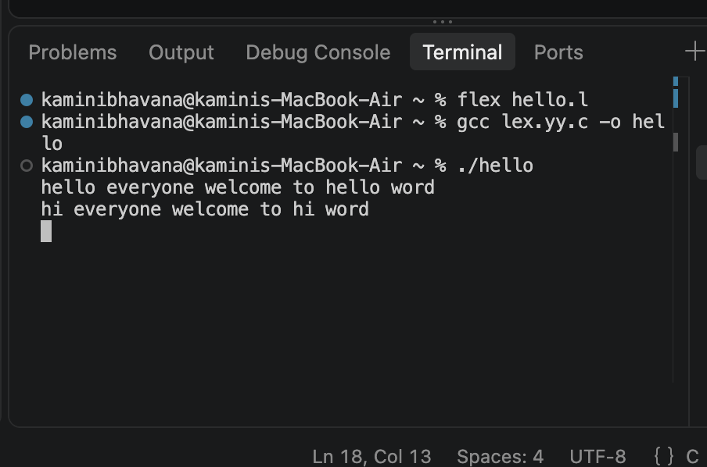
OUTPUT:

